Layer

* Identify hierarchies in the system
* Restrict how layers interact with each other
* Provides separation of concerns and reuse

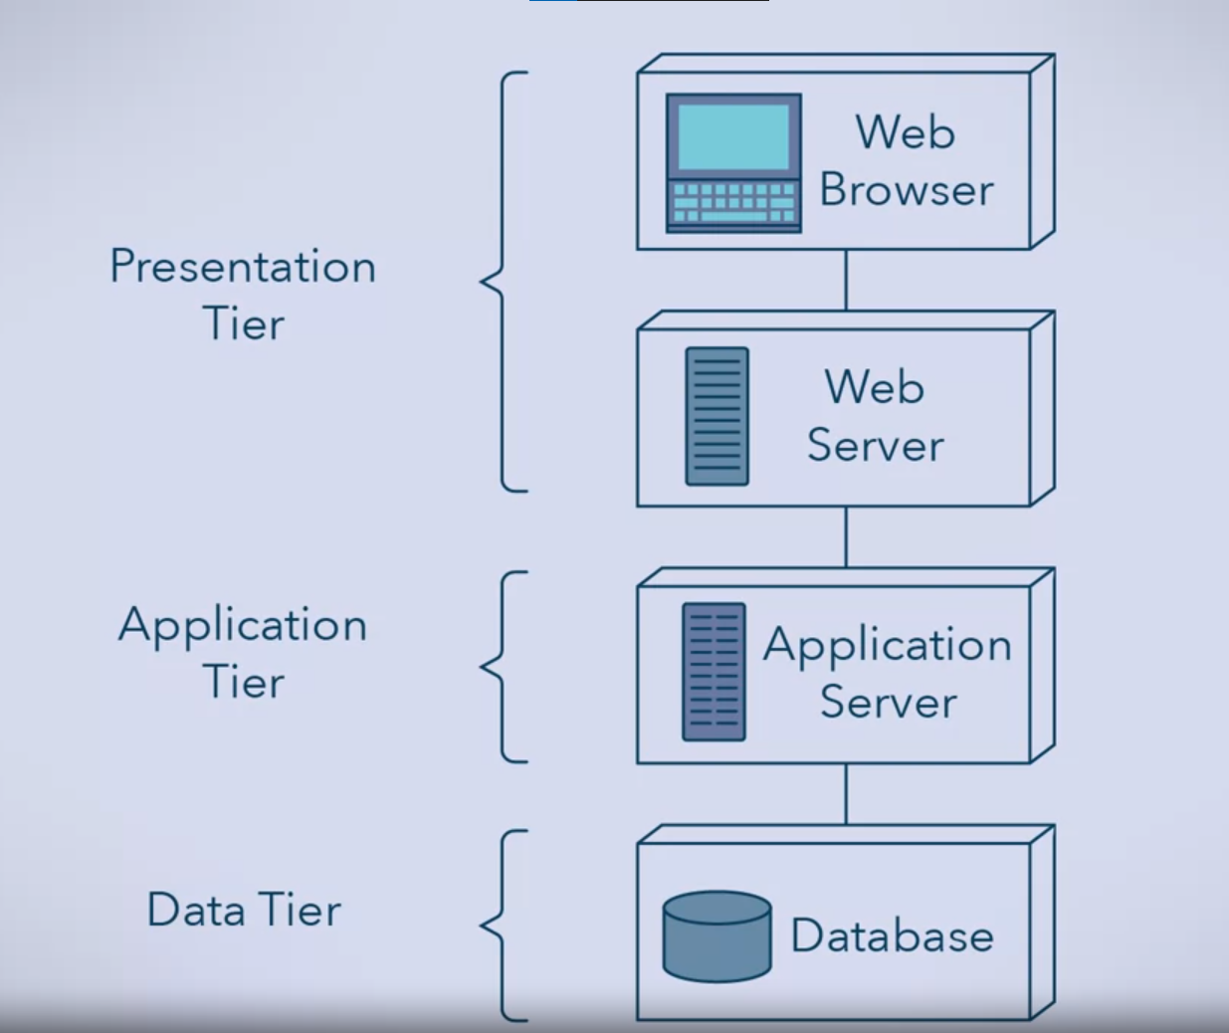

Static Web Page

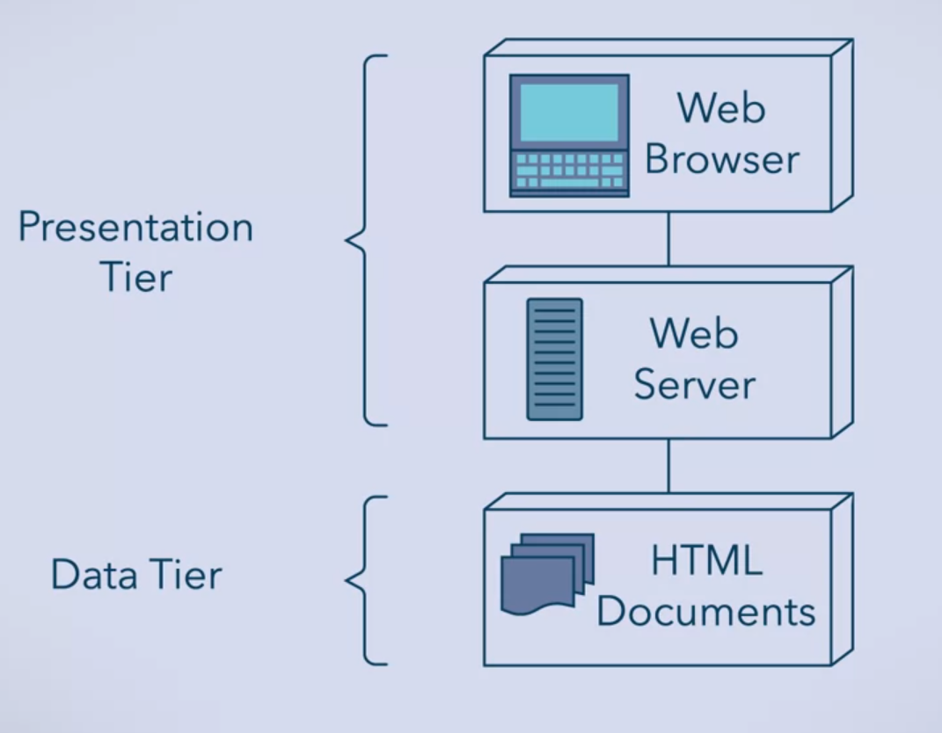

Dynamic

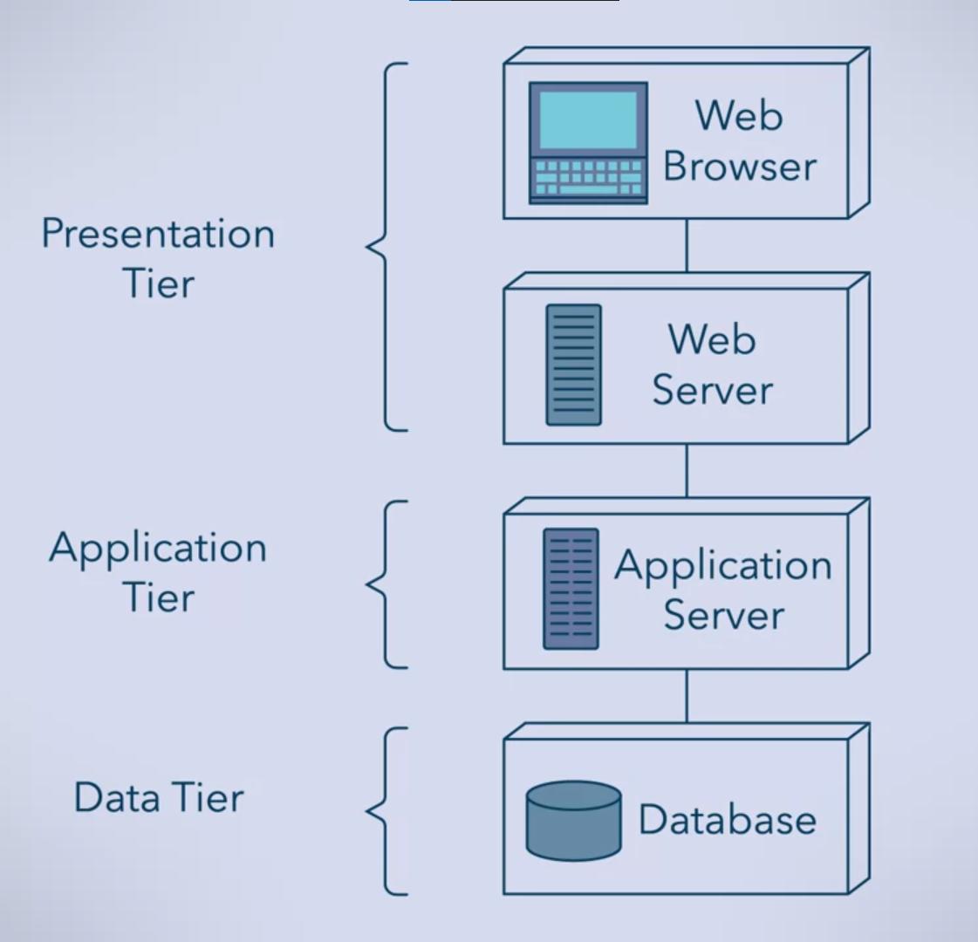

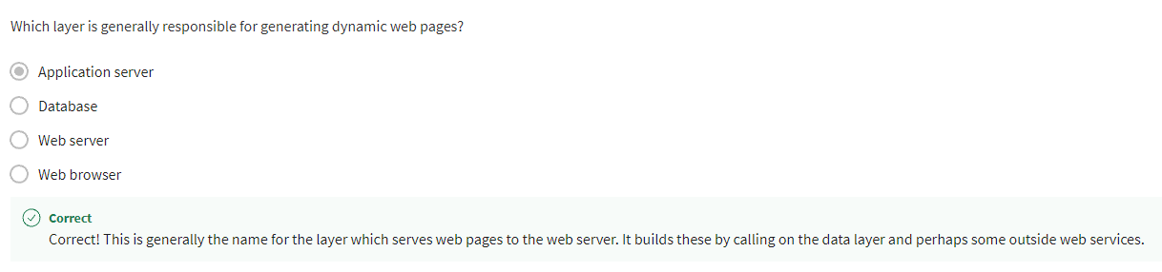

UML of Dynamic

